Activity Sheet 3 Student name:

Theory of compiler lab 414CCS Student ID:

**Section 3**

Program 1: **LEX program to check if a letter is a vowel or consonant (write the rules)**

|  |
| --- |
| %{ #include<stdio.h> int vowel=0; int cons=0; %} %% "a"|"e"|"i"|"o"|"u"|"A"|"E"|"I"|"O"|"U" {printf("You entered Vowel \n");vowel++;} [a-zA-z] {printf("You entered Consonant \n ");cons++;} %% int yywrap() { return 1; } main() { printf("Please enter a letter to check whether it is a vowel or Consonant\n"); yylex(); printf("vowel=%d and Consonent=%d",vowel,cons); } |

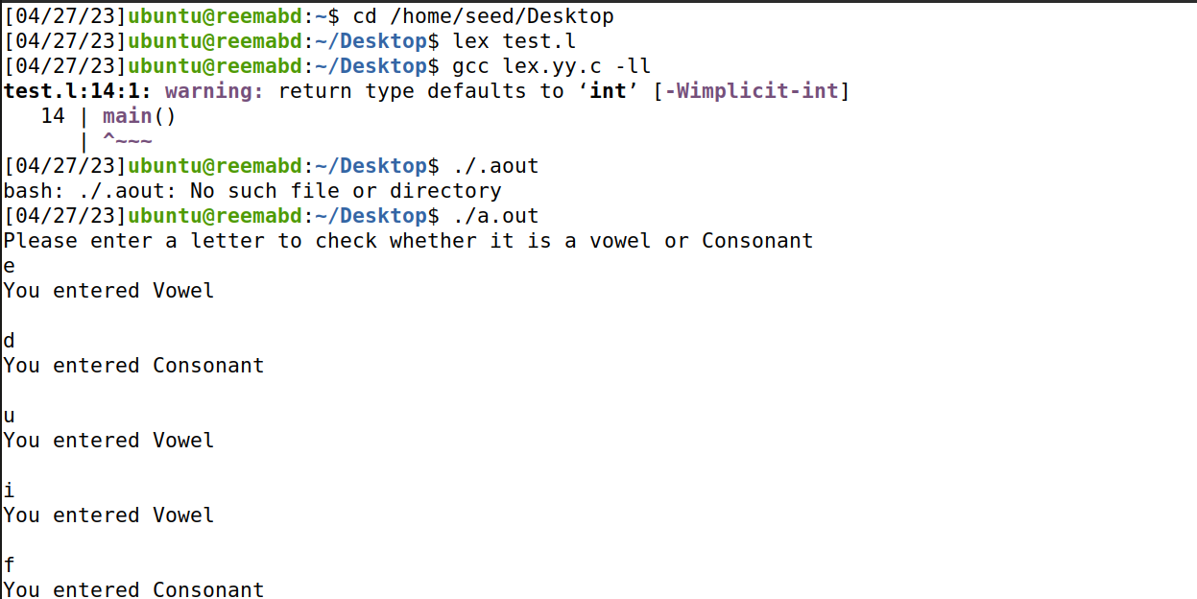

Program 2: **Program check whether a given input is a number or word(write the rules)**

|  |
| --- |
| %{ #include<stdio.h> %} %% [a-zA-Z][a-z|A-Z]* {printf("You entered Word");} [0-9]* {printf("You entered Number");} %% int yywrap() { return 1; } main() { printf("Please enter a string of data\n"); yylex(); } |

